Subsidized Housing List for Carver and Scott Counties
Property name and address | Property phone number | Property type | # of Units
Chaska Village Townhomes  1111 Crosstown Blvd, Chaska, MN 55318 | 952-448-6812 | Family  Project-based section 8 | 28
The Landing  105 E First St., Chaska, MN 55318 | 612-333-9284 | Elderly only  Subsidized | 54
Tahleim (Chaska Manor)  407 Oak St N, Chaska, MN 55318 | 952-361-0310 | Elderly/Disabled-  Project-based section 8 | 58
Waybury  110340 Geske Rd, Chaska, MN 55318 | 952-448-5022 | Elderly/Disabled-  Project-based section 8 | 114
Mayer Elderly Apartments  419 Bluejay Ave, Mayer, MN 55360 | 952-448-4527 | Elderly/Disabled-  Rural development | 10
Deutchland Apartments  600 Broadway East, New Germany, MN 55367 | 507-451-8524 | Family-  Rural development | 8
Peace Villa  300 Faxon Rd, Norwood, MN 55368 | 952-467-3692 | Elderly/Disabled-Rural development | 61
Evergreen Apartments  100 W 3rd St, Waconia, MN 55387 | 952-442-5276 | Elderly/Disabled-  Project-based section 8 | 46
Poplar Ridge Apartments  10 Poplar Ridge Dr, Young America, MN 55397 | 612-874-4416 | Family-  Rural development | 24
Fox Run Apartments  28 West 13th St, Waconia, MN 55387 | 507-451-8524 | Family-  Rural development | 24
Maplecrest Commons  330 West 1st St, Waconia, MN 55387 | 952-977-8569 | Elderly/Disabled-  Rural development | 20
Hillside Apartments  101 Angel St SW, Watertown, MN 55388 | 952-955-3866 | Family-  Rural development | 8
Hilltop I  309 Carter St SW, Watertown, MN 55388 | 952-448-4527 | Elderly/Disabled-  Rural development | 16
Hilltop II  209 Grove Ave, Watertown, MN 55388 | 952-448-4527 | Elderly/Disabled-  Rural development | 16
Riverside Apartments  210 Territorial St E, Watertown, MN 55388 | 952-955-3866 | Elderly/Disabled-  Rural development | 22

Scott County (alpha by city)
Property name and city location | Property phone | Property type
Belle Haven - Belle Plaine | 952-402-9022 | Family- Rural development
Cardinal Ridge - Belle Plaine | 507-775-2109 | Elderly/disabled - Rural development
Belle Plaine Apartments - Belle Plaine | 952-873-4176 | Family - Project-based Section 8
Boessling Lutheran Village Apts. - Belle Plaine | 952-873-4176 | Elderly - Project-based Section 8
Faith Residence (Lutheran Home) - Belle Plaine | 952-873-2033 | Disabled - Project-based Section 8
Britland Apartments - Jordan | 952-402-9022 | Family - Rural development
Schule Haus - Jordan | 952-492-2084 | Elderly/disabled - Project-based Section 8
Liberty Park Apartments - New Prague | 952-758-4991 | Elderly/disabled - Rural development
Millpond Apartments - New Prague | 952-758-4333 | Elderly - Project-based Section 8
Parkside Apartments - New Prague | 507-345-1290 | Family - Rural development
Westgate Apartments - New Prague | 952-758-2299 | Family - Project-based Section 8
Highwood Homes - Prior Lake | 952-447-6961 | Family - Project-based Section 8
Clifton Townhomes – Shakopee | 952-445-4574 | Family – Subsidized Housing
Levee Drive Apartments - Shakopee | 952-445-2001 | Elderly - Project-based Section 8
River Bluff Apartments - Shakopee  (Accessible Space) | 651-645-7271 | Disabled - Project-based Section 8  Must have a TBI or Mobility impairment or be 62+.
Village Apartments - Shakopee | 952-403-1086 | Elderly - Project-based Section 8

Rural Development-Search by county at: www.rurdev.usda.gov/MN
Click on multi-family housing / Scroll down and click on apartments for rent / Search by county.

Rural Development Rental Assistance- Persons with very low and low incomes, the elderly, and persons with disabilities are eligible. Rental assistance is not available for all units.

Project-Based Section 8-Search by county at: www.hud.gov
Click on resources / Click on affordable apartment search / Select a state / You can search by city, county or zip code.

What is the Project Based Section 8 housing program?
Project Based Section 8 housing is a government-funded program that provides rental housing to low-income households in privately owned and managed rental units. The subsidy stays with the building; when you move out, you no longer have the rental assistance. Most units rental cost will be 30% of your household adjusted gross income. There may be a variety of housing types available through this program including single-family homes, townhomes, or apartments.

If you completed a homeless assessment and are on the Coordinated Entry Supportive Housing list, this list is an additional resource for you. You may apply for these properties in addition to the supportive housing list:
Rural development and project based section 8 do not require applicants to be homeless. Coordinated Entry only assists households experiencing homelessness. If you are homeless, call your point of access to see if you are eligible for a homeless assessment AND get on any wait lists you qualify for from the above list. They are two different processes.
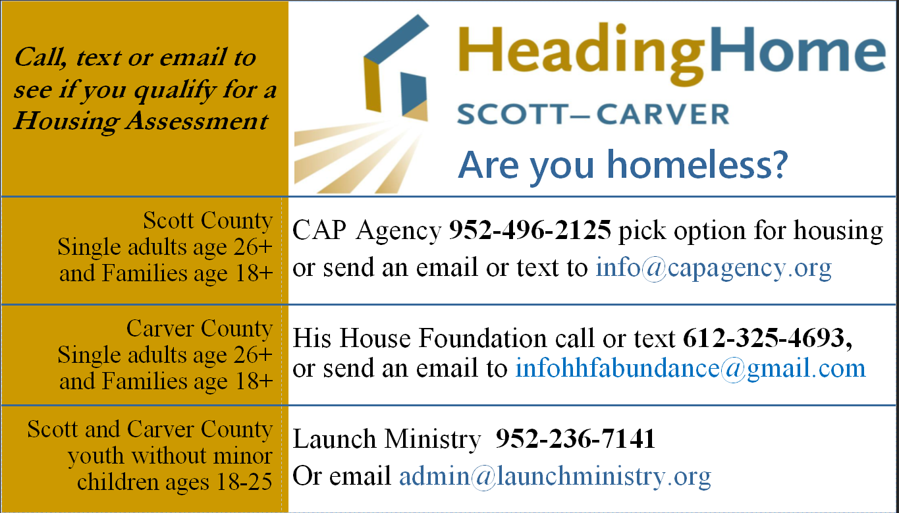
Housing Search Websites:
http://www.housinglink.org
http://www.smrrental.com
http://www.rent411.com
http://minneapolis.craigslist.org/
http://www.hud.gov/apps/section8/
http://hotpads.com
http://www.homes.com
Facebook Marketplace
www.scotttcda.org
www.carvercda.org

